**Assignment 2 - Practicing Databinding**

You learned a lot about Databinding! Time to practice it on your own. In this assignment, you're going to use the different forms of Databinding and see how you may use them in your app.

The snapshot below explains the example app you're starting with and which tasks should be completed as part of this assignment.

Make sure to also answer why you implemented the solution you chose to use.

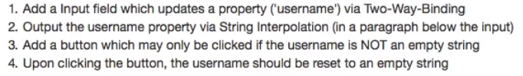

**Questions for this assignment**

**Please complete the tasks outlined in the instructions above. Why did you choose the approach you took? Which problems did you encounter?**

**Download resource files**

* basics-assignment-2-start.zip